

**Sixth-generation high-frequency Schottky SiC diode**

Silicon carbide (SiC) Schottky diodes are semiconductor devices with a larger bandgap than conventional silicon-based Schottky diodes. This makes SiC diodes suitable for high power and high frequency applications, such as traction inverters for electric vehicles (EVs), photovoltaic inverters, power supplies and more. In addition, SiC devices offer a higher breakdown voltage, lower on-state resistance and higher thermal conductivity than their silicon-based counterparts.

The global market for Schottky SiC diodes is expected to grow at a CAGR of 21.4 per cent between 2023 and 2033. This growth is driven by the increasing demand in many applications for high-power, high-efficiency semiconductor devices. Several companies, including WeEn Semiconductors, have made substantial investments in the development of SiC diodes.

WeEn Semiconductors specializes in the development and manufacture of bipolar power devices, including silicon controlled rectifiers (SCRs), power diodes, high-voltage transistors, silicon carbide (SiC) components, and other products commonly used in the automotive, telecommunications, lighting, consumer electronics, etc. industries. With over 50 years of experience and a large research and development team, the company is committed to providing its customers with innovative, high-quality power devices. The WNSC6D10650T diode is one of the products offered by WeEn.

Download the datasheet with the technical features of the SiC SBD here.

Characteristics of diode WNSC6D10650T

The WNSC6D10650T is a 650V, 10A and extremely low Vf(forward voltage drop) Schottky barrier diode manufactured by WeEn Semiconductors. It is a 6th-generation Schottky barrier SiC diode that offers a number of advantages over previous generations. These include a higher breakdown voltage, super low forward voltage drop, high current surge capability and high thermal conductivity. WeEn Gen-6 SiC SBD optimizes the ratio of Schottky contact to PN junction area to achieve ultra-low Vf (typical 1.26V) and provides extremely low on-state resistance through optimizing the doping concentration of EPI layer and wafer thinning. The adoption of the innovative MPS structure obviously increases the current surge capability. The advanced Ag-sintering technology makes the perfect combination of product performance and reliability.

Other features and advantages of the SiC SBD include:

**Ultra Low voltage drop:** the voltage drop (forward voltage) in the conducting state with a current of 10A and at room temperature (25°C) is typically 1.29V, while at 150°C it is 1.45V typical. The lower voltage drop makes the diode suitable for high power and high efficiency requirement applications such as photovoltaic converters, EV drive inverters, LED drivers, power supplies, etc. The graph below shows typical voltage drop values for different current levels and different junction temperature;

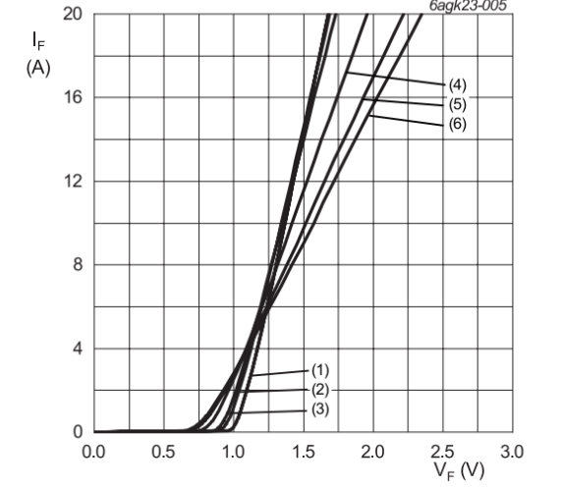

Figure 1: Voltage drop (Vf) as a function of conduction current (If)

Vo = 0.829 V; Rs = 0.0748 Ω (1)Tj= -55°C; (2)Tj=0°C; (3)Tj=25°C; (4)Tj=100°C

(5)Tj=150°C; (6)Tj=175°C

**Low reverse current:** the reverse current (Ir) corresponding to a reverse voltage of 650V and an ambient temperature of 25°C is typically 1μA, while at 150°C it is 15μA. The low value of Ir increases the efficiency of the diode, as less energy is lost as heat when the diode is not in the conduction state. This feature also makes it suitable for high-frequency applications such as power converters and power supplies. The following graph shows typical reverse current values at different junction temperatures and reverse voltage;

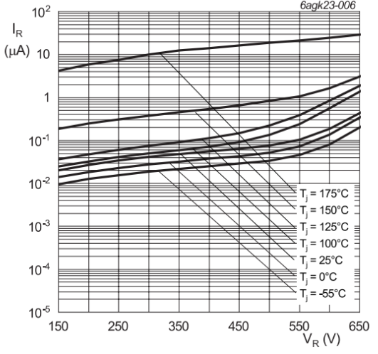

Figure 2: Reverse voltage (Vr) as a function of reverse current (Ir)

**High maximum conduction current:** this value corresponds to the maximum conduction current that the diode can withstand, for a short period, without being damaged. This is an important characteristic that the diode must possess for applications involving transient current and voltage peaks. The following table shows the maximum current (forward surge current, or Ifsm) corresponding to different operating conditions;

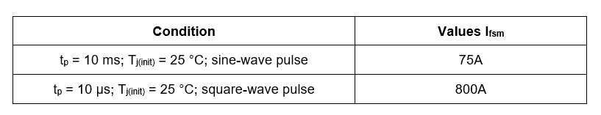

Figure 3: Maximum conduction current under different operating conditions

**Reduction of electromagnetic interference (EMI):** the high-frequency operation of power supplies results in a faster rise and fall of voltage, which is the main cause of electromagnetic interference. Increased EMI can cause the power supply unit to malfunction, which can lead to electric shocks or a fire. The SiC SBD WNSC6D10650T’s is conductive via the Schottky structure where theoretically don’t have a P/N recovering process, which ideally reduces electromagnetic interference (EMI) makes it an ideal solution for power supplies;

**Lower cooling demands:** due to low energy loss in the form of heat. This is determined by the Ultra low foward voltage drop and reverse current leakage, and besides, the very low Qrr will also help to reduce the switching loss to improve the efficiency.

**RoHS compliance:** RoHS stands for Restriction of Hazardous Substances. It is an EU directive restricting the use of certain hazardous substances in electrical and electronic equipment. Hazardous substances subject to RoHS restrictions include lead, cadmium, mercury, hexavalent chromium, polybrominated biphenyls (PBB) and polybrominated diphenyl ethers (PBDE). These substances are dangerous because they can cause health problems or environmental damage.

In addition to best-in-class operational characteristics, the WNSC6D10650T diode is also RoHS compliant, making it a safe and environmentally friendly choice for use in electronic equipment.

**Applications of the WNSC6D10650T diode**

Schottky SiC diodes find a wide range of applications in industry. The WNSC6D10650T diode is available in a DFN 8×8 TO-leadless plastic case designed for high-frequency power supplies. A high-frequency power supply makes its components susceptible to voltage and current peaks, so it is necessary that they have a high capacity to withstand over-currents and surges. In addition, power supplies used in applications such as servers require diodes that have a low voltage drop and cause low EMI in order to maintain high efficiency and low operating temperatures. All these features are present in the Schottky SiC diode WNSC6D10650T, making it the ideal choice for these applications.

In addition to power supplies, the diode can also be used in high-frequency motor drives. These diodes can be used in numerous applications within a frequency converter:

**Freewheeling diode:** these diodes are used to prevent the motor’s EMF (electromotive force) from damaging the drive’s power transistors. When the motor is switched off, the return EMF can flow current in the opposite direction through the power transistors. If not prevented, this can damage the power transistors. Schottky SiC diodes have a fast switching speed, low reverse current and high current handling capability, properties that make them ideal for use as freewheeling diodes in motor drives;

**Chopper diodes:** chopper diodes are used to switch the current in motors on and off, thus allowing the speed of the motor to be controlled. Schottky SiC diodes are widely used as chopper diodes in motor drives due to their high switching speeds.

The WNSC6D10650T diode can also be used in active power factor correctors (APFC). The APFC uses a full-bridge configuration of high-frequency switching diodes to modulate the distorted wave and transform it into a sine wave. Harmonics in the corrected signal are found at the switching frequency and can easily be eliminated by means of filters.

Conclusions

The WNSC6D10650T component manufactured by WeEn Semiconductors is a 6th-generation high-frequency Schottky Barrier SiC diode that can be used in a wide range of applications in all industries. The lowVF and low Qrr make it ideal for use in power supplies of various equipment.

In addition to power supplies, these diodes also find applications in motor drives, LED drivers and power factor (PF) correction systems. The demand for high-power, high-frequency switching diodes that operate efficiently is constantly increasing, and companies such as WeEn Semiconductors are continuously introducing ever more innovative and efficient diodes to the market.