Second-Generation Super junction MOSFET: Beginning of a New Era
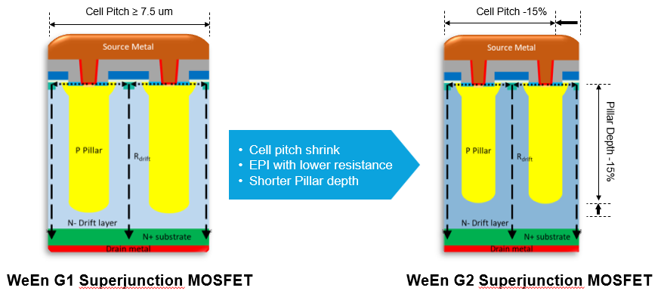

According to a survey by Global Market Insights, Super Junction MOSFETs captured over 30% market share in the energy and power sector in 2023. Their applications span multiple domains, including electric vehicle charging stations, server and data center power supplies, LED drivers, solar inverters and home appliance controls. The global Super Junction MOSFET market is projected to achieve a compound annual growth rate (CAGR) exceeding 11.5% by 2032. Super Junction MOSFETs offers robust assurance to customers seeking exceptional performance and stability backed by WeEn’s well-established reliability standards, comprehensive supply chain systems and continuously evolving technological roadmaps. WeEn currently offers two series of Super Junction MOSFETs: G1 and G2. Our G2 Super Junction MOSFETs feature advanced design improvements, such as reduced cell pitch, low-resistance epitaxial layers, and shorter P-column depths. These innovations significantly reduce the device’s on-state resistance. Simultaneously, we’ve precisely controlled the charge balance of the super junction structure, ensuring excellent avalanche ruggedness and low capacitive losses. This results in a balanced, outstanding performance in both hard and soft-switching applications that demand high efficiency, reliability, and superior thermal management.

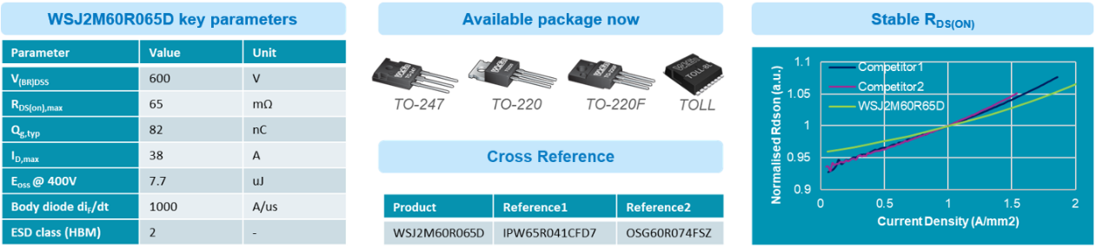
The WSJ2M60R065D is one of the flagship products in WeEn’s G2 Super Junction MOSFET lineup. Available in various packages including TO-220, TO-220F, TO-247, and TOLL. It particularly excels in terms of on-state resistance. Compared to competitors’ products, the WSJ2M60R065D maintains more stable on-state resistance across different current densities. Within its maximum continuous current range, the resistance variation does not exceed 10%. This stability provides customers with reliable performance data. Furthermore, the WSJ2M60R065D adapts well to applications with varying power requirements, demonstrating exceptional performance across diverse and complex operating environments.

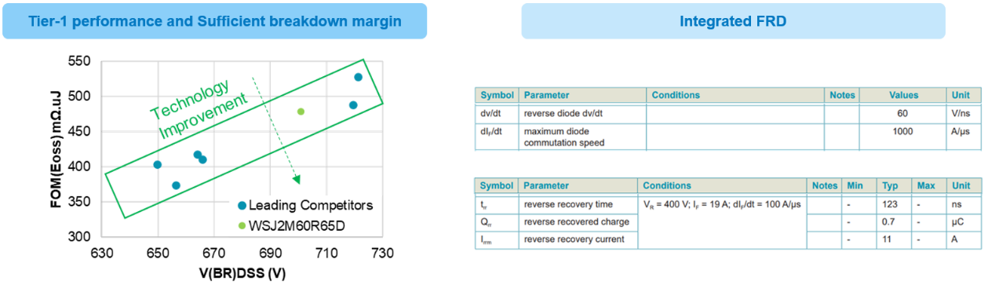
WeEn’s G2 MOSFETs are at the forefront of performance, with their Figure of Merit (FOM) on par with top global competitors. While ensuring stringent yield and process control, WeEn reserves more breakdown voltage margin for customers. Our 600V devices approach the standards of 650V devices available on the market, thoroughly safeguarding the reliability of customer applications. Moreover, the G2 MOSFET integrates a finely tuned fast recovery body diode, with a reverse recovery time (Trr) of only 123 ns. The body diode can withstand a commutation speed of 1000 A/μs without damage. This makes the WSJ2M60R065D particularly suitable for Zero Voltage Switching (ZVS) applications in soft-switching topologies, delivering high efficiency while handling irregular operating conditions.
However, the WSJ2M60R065D is not limited to soft-switching applications. It also demonstrates excellent performance in hard-switching applications. The WSJ2M60R065D offers significant advantages in terms of lower capacitive losses (Eoss) compared to top competitors. Additionally, its normalized ruggedness is significantly higher than the industry standard, enabling it to withstand higher overvoltage and oscillation. It also demonstrates stable and safe performance in hard-switching topologies such as Power Factor Correction (PFC) circuits.

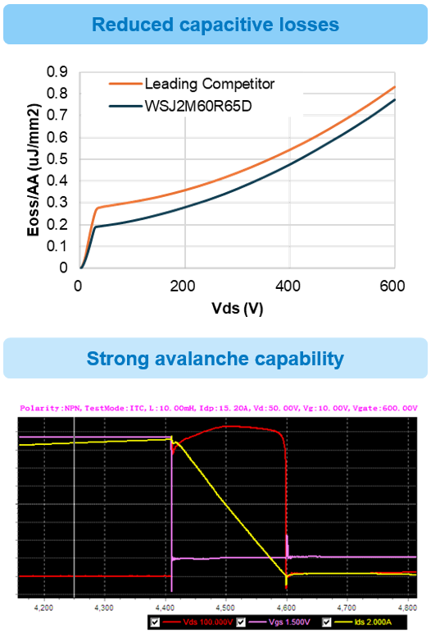
WeEn consistently adheres to rigorous and reliable quality assessment practices. In accelerated aging tests, we maintain a zero-tolerance policy for product failures. WeEn MOSFET products demonstrate excellent consistency in performance during high-temperature stress aging tests at 168, 500, and 1000 hours. Furthermore, we conduct additional reviews of the ESD (Electrostatic Discharge) capability of the device to minimize quality issues during production, packaging, and transportation. The WSJ2M60R065D demonstrates a robust quality level with a CDM (Charged Device Model) capability exceeding 2000V and an HBM (Human Body Model) capability of over 4000V.
